Department of computer science and engineering
KRISHNA ENGINEERING COLLEGE
95, Loni Road, Mohan Nagar, Ghaziabad (Uttar Pradesh), Pin-201007



CompilerDesignLab (RCS-652)

Name – Ritik bansal
Roll no.-1816110162
Sec-3C

Program 1:
AIM: WAP to check whether the entered string is accepted or not for a given grammar.

PROGRAM:

#include <iostream>
#include <string.h>
#include <stdlib.h>
using namespace std;
char a[100];
int n, i;
int main()

{
cout << "\nenter string: ";
cin >> a;
n = strlen(a);

if (a[0] == 'a' && (a[n - 1] == 'a' || a[n - 1] == 'b') && a[n - 2] == 'c')
{
for (i = 1; i < n - 2; i++)
{
if (a[i] != 'b')
{
cout << "string is not accepted";
exit(0);
}
}
cout << "string is accepted";
}

else
cout << "string is not accepted";
}
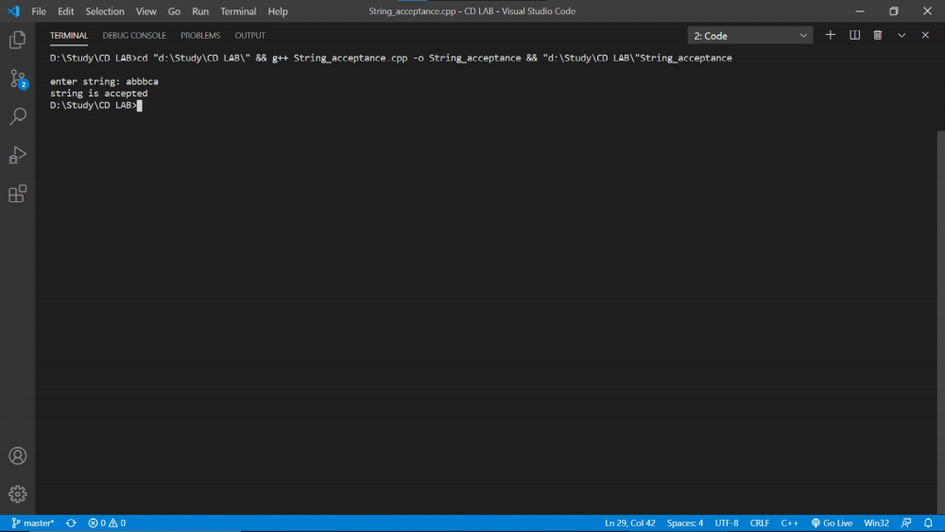

Program 2

AIM: WAP to convert infix expression to postfix expression.
PROGRAM:
#include<stdio.h>
#include <ctype.h>
char stack[50];
int top=-1;
void push(char item) {
stack[++top] = item;
}
char pop() {
if (top==-1) {
return -1;
}
else {
return stack[top--];
}
}
int priority(char p)
{
if (p == '(')
return 0;
if (p == '+' || p == '-')
return 1;
if (p == '*' || p == '/')
return 2;
}
int main() {
char i, str[50];
printf("Enter infix expression:");
scanf(" %s", str);
char *ptr=str;
while (*ptr != '\0') {
if (isalnum(*ptr)) {
printf("%c", *ptr);
}
else if (*ptr == '(')
push(*ptr);
else if (*ptr == ')')
{
while ((i = pop()) != '(')
printf("%c", i);
}
else
{
while (priority(stack[top]) >= priority(*ptr)) {
printf("%c", pop());
}
push(*ptr);
}
ptr++;
}
while (top != -1)
{
printf("%c", pop());
}
return 0;

}
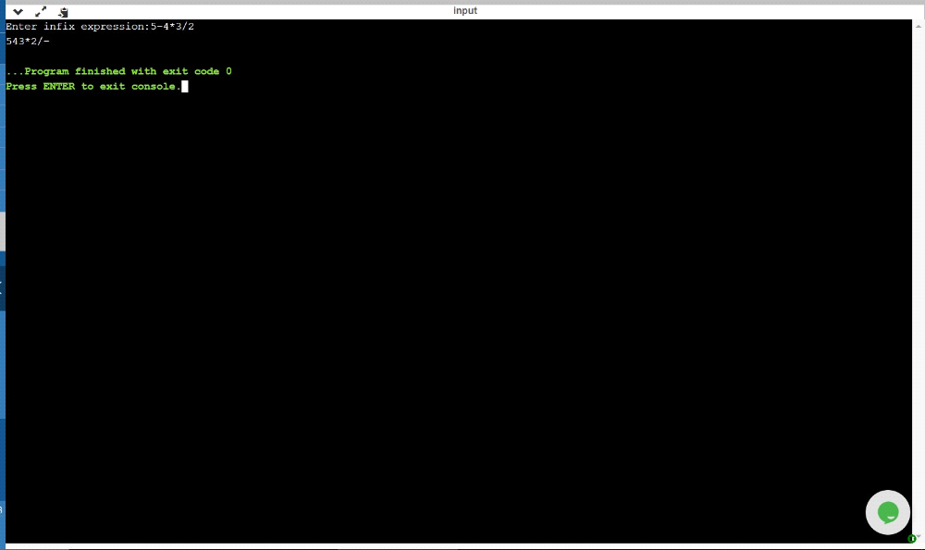

Program 3

AIM: WAP to convert infix expression to prefix expression.

PROGRAM:
#include<stdio.h>
#include <ctype.h>
char stack[50];
int top=-1;
void push(char item) {
stack[++top] = item;
}
char pop() {
if (top==-1) {
return -1;
}
else {
return stack[top--];
}
}
int priority(char p)
{
if (p == '(')
return 0;
if (p == '+' || p == '-')
return 1;
if (p == '*' || p == '/')
return 2;
}
int main() {
char i, str[50];
printf("Enter infix expression:");
scanf(" %s", str);
char *ptr=str;
while (*ptr != '\0') {
if (isalnum(*ptr)) {
printf("%c", *ptr);
}
else if (*ptr == '(')
push(*ptr);
else if (*ptr == ')')
{
while ((i = pop()) != '(')
printf("%c", i);
}
else
{
while (priority(stack[top]) >= priority(*ptr)) {
printf("%c", pop());
}
push(*ptr);
}
ptr++;
}
while (top != -1)
{
printf("%c", pop());
}
return 0;

}
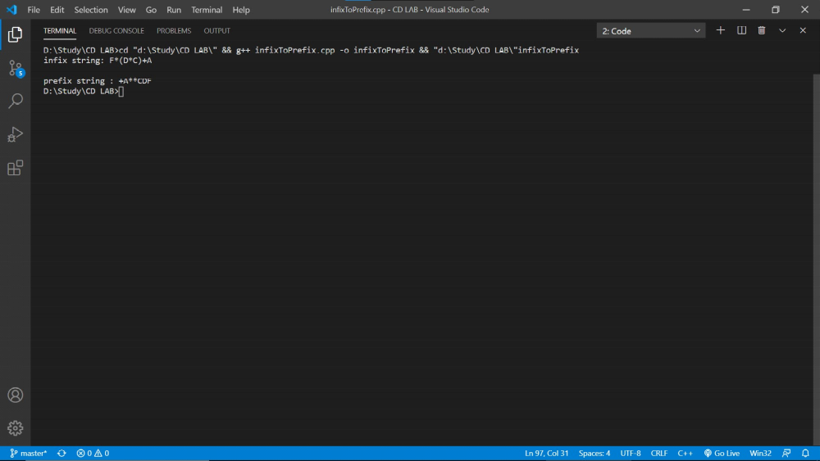

Program 4

AIM: WAP to find the no. of tokens and list them according to their category in an expression (given/entered)

PROGRAM:
#include <stdio.h>
#include <ctype.h>
int main()
{
char i, str[50];
int opr = 0, var = 0, con = 0;
printf("Enter expression:");
scanf(" %s", str);
char *ptr = str;
while (*ptr != '\0')
{
if (isalpha(*ptr))
{
var++;
while (isalnum(*ptr))
ptr++;
}
else if (!isalnum(*ptr))
{
opr++;
while (!isalnum(*ptr))
ptr++;
}
else if (isdigit(*ptr))
{
con++;
while (isdigit(*ptr))
ptr++;
}
}
printf("variable=%d\n", var);
printf("operator=%d\n", opr);
printf("constant=%d\n", con);
printf("tokens=%d", var + opr + con);
return 0;
}
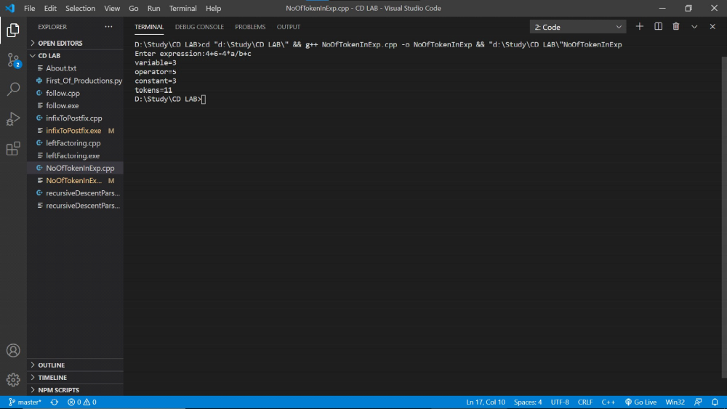

Program 5

AIM: WAP to construct an NFA from a regular expression (given) and display the transition table of NFA constructed.
PROGRAM:
#include <iostream>
#include <conio.h>
#include <stdio.h>
#include <string.h>
using namespace std;
int main()
{
char s[10];
int n, init = 0, fin = 1;
cout << "enter R.E\n";
gets(s);
n = strlen(s);
for (int i = 0; i < n; i++)
{
if (s[i] == '*')
fin += 2;
if (s[i] == '.')
fin += 1;
if (s[i] == '/')
fin += 4;
fin += 1;
if (s[i] == '/')
fin += 4;
}

char c = 238;
int i = 0;
int ch;
if (s[0] >= 97 && s[0] <= 122)
ch = 1;
if (s[0] == '(' && s[4] == ')')
ch = 2;
switch (ch)
{
case 1:
if (s[i + 1] == '/')
{
if (s[i + 2] >= 97 && s[i + 2] <= 122)
{
cout << "\n"
<< init + 2 << "--" << s[i] << "-->" << init + 3;
cout << "\n"
<< init + 4 << "--" << s[i + 2] << "-->" << init + 5;
goto pt1;
}
}

case 2:
if (s[i + 1] >= 97 && s[i + 1] <= 122)
if (s[i + 2] == '/')
{
if (s[i + 3] >= 97 && s[i + 3] <= 122)
{
cout << "\n"
<< init + 2 << "--" << s[i + 1] << "-->" << init + 3;
cout << "\n"
<< init + 4 << "--" << s[i + 3] << "-->" << init + 5;

if (s[i + 5] == '*')
{
goto pt;
}
else
goto pt1;
}
}
}

pt:
cout << "\n"
<< init << "--" << c << "-->" << init + 1;
cout << "\n"
<< init << "--" << c << "-->" << fin;

pt1:
cout << "\n"
<< init + 1 << "--" << c << "-->" << init + 2;
cout << "\n"
<< init + 1 << "--" << c << "-->" << init + 4;
cout << "\n"
<< init + 3 << "--" << c << "-->" << init + 6;
cout << "\n"
<< init + 5 << "--" << c << "-->" << init + 6;
cout << "\n"
<< init + 6 << "--" << c << "-->" << init + 1;
cout << "\n"
<< init + 6 << "--" << c << "-->" << fin;
return 0;
}
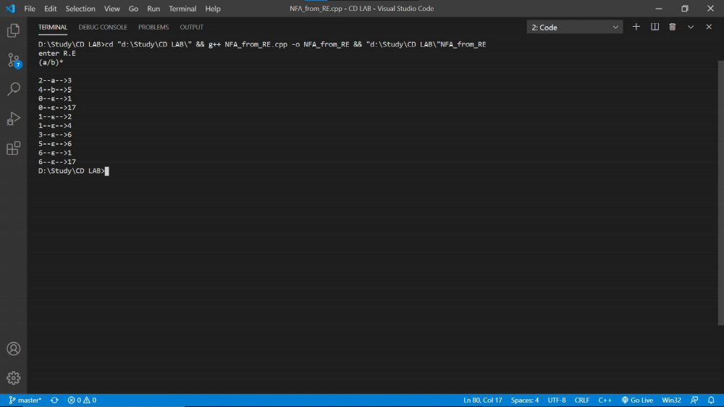

Program 6

AIM: WAP to compute LEADING and TRAILING sets of a grammar(given).

Grammar: E( E+T | T
T( T*F | F
F( (E) | id

PROGRAM :
#include <iostream>
using namespace std;
int main()
{
char s, l[20], r[10], lead[10], trail[10];
int n, j, m;
for (int i = 0; i < 10; i++)
{
lead[i] = NULL;
trail[i] = NULL;
}
cout << "\nenter total no. of productions";
cin >> n;
int k = 0;
m = 0;
for (int i = 0; i < n; i++)
{
cout << "\nenter the LHS of production";
cin >> l[i];
cout << "\nenter the RHS of production";
cin >> r;
for (int j = 0; j < 2; j++)
{
if ((r[j] == '(') || r[j] == ')' || r[j] == '*' || r[j] == '+' || r[j] == '-' || r[j] == '/')
{
lead[k] = r[j];
k = k + 1;
}
if ((r[j] == 'i') && (r[j + 1] == 'd'))
{
lead[k] = r[j];
lead[k + 1] = r[j + 1];
k = k + 1;
}
}
for (j = 1; j <= 2; j++)
{
if ((r[j] == '(') || r[j] == ')' || r[j] == '*' || r[j] == '+' || r[j] == '-' || r[j] == '/')
{
trail[m] = r[j];
m = m + 1;
}
if ((r[j - 1] == 'i') && (r[j] == 'd'))
{
trail[m] = r[j - 1];
trail[m + 1] = r[j];
m = m + 1;
}
}
}
cout << "\nthe Leading(A) is :\n";
cout << "{ ";
for (int i = 0; i < k; i++)
{
if ((lead[i] == 'i') && (lead[i + 1] == 'd'))
cout << lead[i] << lead[i + 1] << " ";
else
cout << lead[i] << " ";
}
cout << "}";
cout << "\nthe Trailing(A) is :\n";
cout << "{ ";
for (int i = 0; i < m; i++)
{
if ((trail[i] == 'i') && (trail[i + 1] == 'd'))
cout << trail[i] << trail[i + 1] << " ";
else
cout << trail[i] << " ";
}
cout << "}";
}
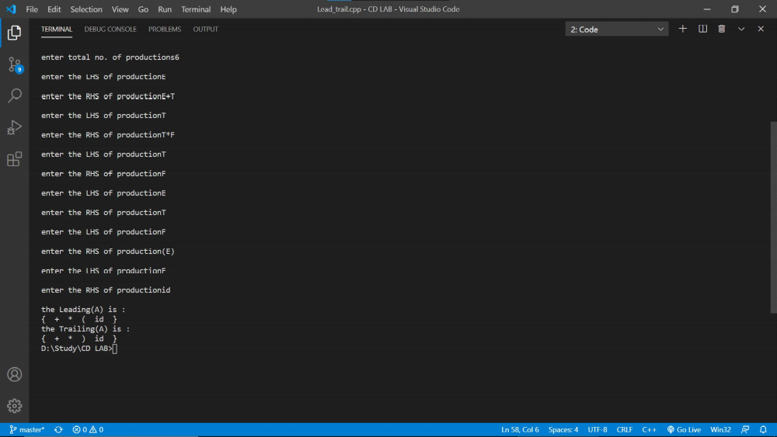

Program 7

AIM: WAP to calculate FIRST.

PROGRAM:
def FIR(str):
try:
if(not str[2].isupper()):
first[str[0]].append(str[2])
# return first[str[0]]
else:
for i in productions:
if(i[0] == str[2]):
FIR(str[0]+i[1:])
if('$' in first[str[0]]):
FIR(str[0:2]+str[3:])
except:
pass

productions = []
n = int(input("How many productions?"))
first = {}
for i in range(n):
productions.append(input())
str = productions[i]
if (str[0] not in first):
first[str[0]] = []
FIR(str)
for i in productions:
FIR(i)
for i in first:
print(i+"=", set(first[i]))

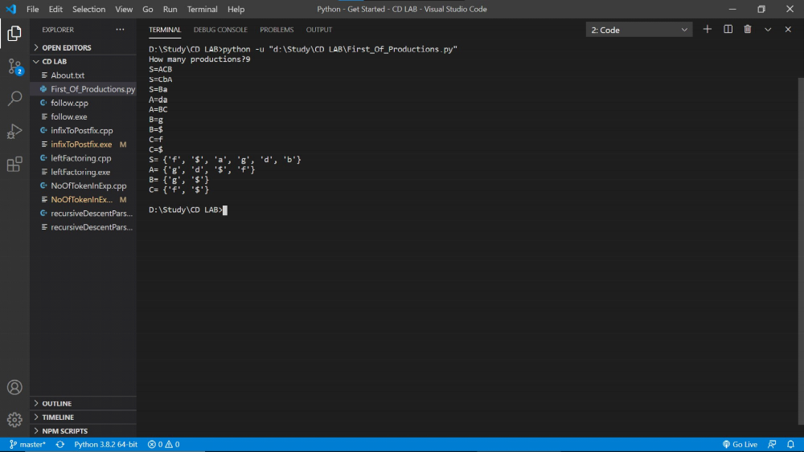

Program 8

AIM: WAP to calculate FOLLOW.

PROGRAM:
#include <stdio.h>
#include <string.h>
#include <cctype>
int n, m = 0, p, i = 0, j = 0;
char a[10][10], f[10];
void follow(char c);
void first(char c);
int main()
{
int i, z;
char c, ch;
printf("Enter the no.of productions:");
scanf("%d", &n);
printf("Enter the productions(epsilon=$):\n");
for (i = 0; i < n; i++)
scanf("%s%c", a[i], &ch);

do
{
m = 0;
printf("Enter the element whose FOLLOW is to be found:");

scanf("%c", &c);
follow(c);
printf("FOLLOW(%c) = { ", c);
for (i = 0; i < m; i++)
printf("%c ", f[i]);
printf(" }\n");
printf("Do you want to continue(0/1)?");
scanf("%d%c", &z, &ch);
} while (z == 1);
}
void follow(char c)
{

if (a[0][0] == c)
f[m++] = '$';
for (i = 0; i < n; i++)
{
for (j = 2; j < strlen(a[i]); j++)
{
if (a[i][j] == c)
{
if (a[i][j + 1] != '\0')
first(a[i][j + 1]);

if (a[i][j + 1] == '\0' && c != a[i][0])
follow(a[i][0]);
}
}
}
}
void first(char c)
{
int k;
if (!(isupper(c)))
f[m++] = c;
for (k = 0; k < n; k++)
{
if (a[k][0] == c)
{
if (a[k][2] == '$')
follow(a[i][0]);
else if (islower(a[k][2]))
f[m++] = a[k][2];
else
first(a[k][2]);
}
}
}
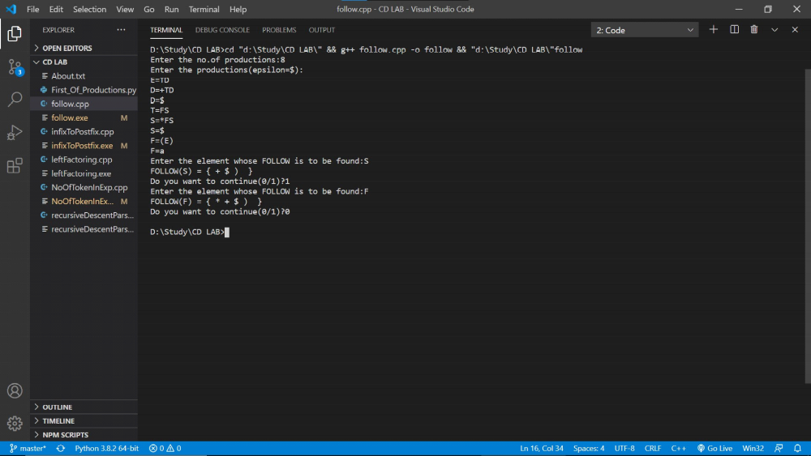

Program 9

AIM: WAP in C to check whether the Grammar is Left-recursive and remove left recursion.

PROGRAM:
#include <stdio.h>
#include <string.h>
#define SIZE 10
int main()
{
char non_terminal;
char beta, alpha;
int num;
char production[10][SIZE];
int index = 3; /* starting of the string following "->" */
printf("Enter Number of Production : ");
scanf("%d", &num);
printf("Enter the grammar as E->E-A :\n");
for (int i = 0; i < num; i++)
{
scanf("%s", production[i]);
}
for (int i = 0; i < num; i++)
{
printf("\nGRAMMAR : : : %s", production[i]);
non_terminal = production[i][0];
if (non_terminal == production[i][index])
{
alpha = production[i][index + 1];
printf(" is left recursive.\n");
while (production[i][index] != 0 && production[i][index] != '|')
index++;
if (production[i][index] != 0)
{
beta = production[i][index + 1];
printf("Grammar without left recursion:\n");
printf("%c->%c%c\'", non_terminal, beta, non_terminal);
printf("\n%c\'->%c%c\'|E\n", non_terminal, alpha, non_terminal);
}
else
printf(" can't be reduced\n");
}
else
printf(" is not left recursive.\n");
index = 3;
}
}
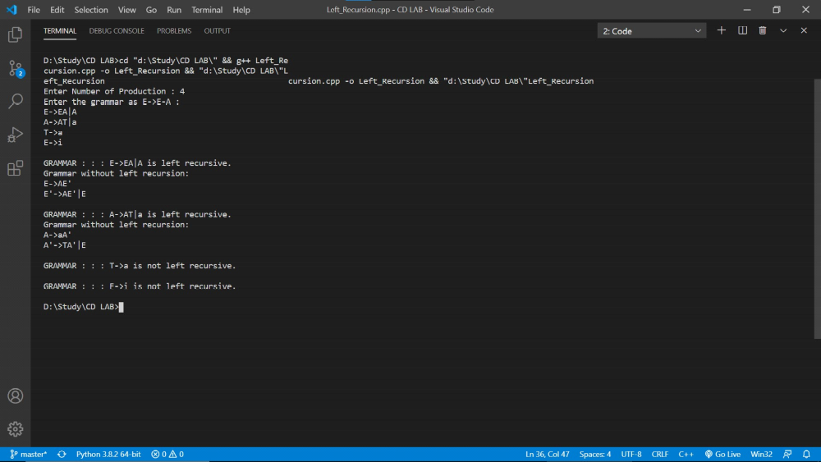

Program-10

AIM: WAP in C to draw a SLR parsing table for a given grammar

PROGRAM:#include <iostream>
#include <string.h>
#include <stdlib.h>
#include <stdio.h>

using namespace std;

char terminals[100] = {};
int no_t;
char non_terminals[100] = {};
int no_nt;
char goto_table[100][100];
char reduce[20][20];
char follow[20][20];
char fo_co[20][20];
char first[20][20];

struct state
{
int prod_count;
char prod[100][100] = {{}};
};

void add_dots(struct state *I)
{
for (int i = 0; i < I->prod_count; i++)
{
for (int j = 99; j > 3; j--)
I->prod[i][j] = I->prod[i][j - 1];
I->prod[i][3] = '.';
}
}

void augument(struct state *S, struct state *I)
{
if (I->prod[0][0] == 'S')
strcpy(S->prod[0], "Z->.S");
else
{
strcpy(S->prod[0], "S->.");
S->prod[0][4] = I->prod[0][0];
}
S->prod_count++;
}

void get_prods(struct state *I)
{
cout << "Enter the number of productions:\n";
cin >> I->prod_count;
cout << "Enter the number of non terminals:" << endl;
cin >> no_nt;
cout << "Enter the non terminals one by one:" << endl;
for (int i = 0; i < no_nt; i++)
cin >> non_terminals[i];
cout << "Enter the number of terminals:" << endl;
cin >> no_t;
cout << "Enter the terminals (single lettered) one by one:" << endl;
for (int i = 0; i < no_t; i++)
cin >> terminals[i];
cout << "Enter the productions one by one in form (S->ABc):\n";
for (int i = 0; i < I->prod_count; i++)
{
cin >> I->prod[i];
}
}

bool is_non_terminal(char a)
{
if (a >= 'A' && a <= 'Z')
return true;
else
return false;
}

bool in_state(struct state *I, char *a)
{
for (int i = 0; i < I->prod_count; i++)
{
if (!strcmp(I->prod[i], a))
return true;
}
return false;
}

char char_after_dot(char a[100])
{
char b;
for (int i = 0; i < strlen(a); i++)
if (a[i] == '.')
{
b = a[i + 1];
return b;
}
}

char *move_dot(char b[100], int len)
{
char a[100] = {};
strcpy(a, b);
for (int i = 0; i < len; i++)
{
if (a[i] == '.')
{
swap(a[i], a[i + 1]);
break;
}
}
return &a[0];
}

bool same_state(struct state *I0, struct state *I)
{

if (I0->prod_count != I->prod_count)
return false;

for (int i = 0; i < I0->prod_count; i++)
{
int flag = 0;
for (int j = 0; j < I->prod_count; j++)
if (strcmp(I0->prod[i], I->prod[j]) == 0)
flag = 1;
if (flag == 0)
return false;
}
return true;
}

void closure(struct state *I, struct state *I0)
{
char a = {};
for (int i = 0; i < I0->prod_count; i++)
{
a = char_after_dot(I0->prod[i]);
if (is_non_terminal(a))
{
for (int j = 0; j < I->prod_count; j++)
{
if (I->prod[j][0] == a)
{
if (!in_state(I0, I->prod[j]))
{
strcpy(I0->prod[I0->prod_count], I->prod[j]);
I0->prod_count++;
}
}
}
}
}
}

void goto_state(struct state *I, struct state *S, char a)
{
int time = 1;
for (int i = 0; i < I->prod_count; i++)
{
if (char_after_dot(I->prod[i]) == a)
{
if (time == 1)
{
time++;
}
strcpy(S->prod[S->prod_count], move_dot(I->prod[i], strlen(I->prod[i])));
S->prod_count++;
}
}
}

void print_prods(struct state *I)
{
for (int i = 0; i < I->prod_count; i++)
printf("%s\n", I->prod[i]);
cout << endl;
}

bool in_array(char a[20], char b)
{
for (int i = 0; i < strlen(a); i++)
if (a[i] == b)
return true;
return false;
}

char *chars_after_dots(struct state *I)
{
char a[20] = {};
for (int i = 0; i < I->prod_count; i++)
{
if (!in_array(a, char_after_dot(I->prod[i])))
{
a[strlen(a)] = char_after_dot(I->prod[i]);
}
}
return &a[0];
}

void cleanup_prods(struct state *I)
{
char a[100] = {};
for (int i = 0; i < I->prod_count; i++)
strcpy(I->prod[i], a);
I->prod_count = 0;
}

int return_index(char a)
{
for (int i = 0; i < no_t; i++)
if (terminals[i] == a)
return i;
for (int i = 0; i < no_nt; i++)
if (non_terminals[i] == a)
return no_t + i;
}

void print_shift_table(int state_count)
{
cout << endl
<< "********Shift Actions*********" << endl
<< endl;
cout << "\t";
for (int i = 0; i < no_t; i++)
cout << terminals[i] << "\t";
for (int i = 0; i < no_nt; i++)
cout << non_terminals[i] << "\t";
cout << endl;
for (int i = 0; i < state_count; i++)
{
int arr[no_nt + no_t] = {-1};
for (int j = 0; j < state_count; j++)
{
if (goto_table[i][j] != '~')
{
arr[return_index(goto_table[i][j])] = j;
}
}
cout << "I" << i << "\t";
for (int j = 0; j < no_nt + no_t; j++)
{
if (i == 1 && j == no_t - 1)
cout << "ACC"
<< "\t";
if (arr[j] == -1 || arr[j] == 0)
cout << "\t";
else
{
if (j < no_t)
cout << "S" << arr[j] << "\t";
else
cout << arr[j] << "\t";
}
}
cout << "\n";
}
}

int get_index(char c, char *a)
{
for (int i = 0; i < strlen(a); i++)
if (a[i] == c)
return i;
}

void add_dot_at_end(struct state *I)
{
for (int i = 0; i < I->prod_count; i++)
{
strcat(I->prod[i], ".");
}
}

void add_to_first(int n, char b)
{
for (int i = 0; i < strlen(first[n]); i++)
if (first[n][i] == b)
return;
first[n][strlen(first[n])] = b;
}

void add_to_first(int m, int n)
{
for (int i = 0; i < strlen(first[n]); i++)
{
int flag = 0;
for (int j = 0; j < strlen(first[m]); j++)
{
if (first[n][i] == first[m][j])
flag = 1;
}
if (flag == 0)
add_to_first(m, first[n][i]);
}
}

void add_to_follow(int n, char b)
{
for (int i = 0; i < strlen(follow[n]); i++)
if (follow[n][i] == b)
return;
follow[n][strlen(follow[n])] = b;
}

void add_to_follow(int m, int n)
{
for (int i = 0; i < strlen(follow[n]); i++)
{
int flag = 0;
for (int j = 0; j < strlen(follow[m]); j++)
{
if (follow[n][i] == follow[m][j])
flag = 1;
}
if (flag == 0)
add_to_follow(m, follow[n][i]);
}
}

void add_to_follow_first(int m, int n)
{
for (int i = 0; i < strlen(first[n]); i++)
{
int flag = 0;
for (int j = 0; j < strlen(follow[m]); j++)
{
if (first[n][i] == follow[m][j])
flag = 1;
}
if (flag == 0)
add_to_follow(m, first[n][i]);
}
}

void find_first(struct state *I)
{
for (int i = 0; i < no_nt; i++)
{
for (int j = 0; j < I->prod_count; j++)
{
if (I->prod[j][0] == non_terminals[i])
{
if (!is_non_terminal(I->prod[j][3]))
{
add_to_first(i, I->prod[j][3]);
}
}
}
}
}

void find_follow(struct state *I)
{
for (int i = 0; i < no_nt; i++)
{
for (int j = 0; j < I->prod_count; j++)
{
for (int k = 3; k < strlen(I->prod[j]); k++)
{
if (I->prod[j][k] == non_terminals[i])
{
if (I->prod[j][k + 1] != '\0')
{
if (!is_non_terminal(I->prod[j][k + 1]))
{
add_to_follow(i, I->prod[j][k + 1]);
}
}
}
}
}
}
}

int get_index(int *arr, int n)
{
for (int i = 0; i < no_t; i++)
{
if (arr[i] == n)
return i;
}
return -1;
}

void print_reduce_table(int state_count, int *no_re, struct state *temp1)
{
cout << "**********Reduce actions**********" << endl
<< endl;
cout << "\t";
int arr[temp1->prod_count][no_t] = {-1};
for (int i = 0; i < no_t; i++)
{
cout << terminals[i] << "\t";
}
cout << endl;
for (int i = 0; i < temp1->prod_count; i++)
{
int n = no_re[i];
for (int j = 0; j < strlen(follow[return_index(temp1->prod[i][0]) - no_t]); j++)
{
for (int k = 0; k < no_t; k++)
{
if (follow[return_index(temp1->prod[i][0]) - no_t][j] == terminals[k])
arr[i][k] = i + 1;
}
}
cout << "I" << n << "\t";
for (int j = 0; j < no_t; j++)
{
if (arr[i][j] != -1 && arr[i][j] != 0 && arr[i][j] < state_count)
cout << "R" << arr[i][j] << "\t";
else
cout << "\t";
}
cout << endl;
}
}

int main()
{
struct state init;
struct state temp;
struct state temp1;
int state_count = 1;
get_prods(&init);
temp = init;
temp1 = temp;
add_dots(&init);

for (int i = 0; i < 100; i++)
for (int j = 0; j < 100; j++)
goto_table[i][j] = '~';

struct state I[50];
augument(&I[0], &init);
closure(&init, &I[0]);
cout << "\nI0:\n";
print_prods(&I[0]);

char characters[20] = {};
for (int i = 0; i < state_count; i++)
{
char characters[20] = {};
for (int z = 0; z < I[i].prod_count; z++)
if (!in_array(characters, char_after_dot(I[i].prod[z])))
characters[strlen(characters)] = char_after_dot(I[i].prod[z]);

for (int j = 0; j < strlen(characters); j++)
{
goto_state(&I[i], &I[state_count], characters[j]);
closure(&init, &I[state_count]);
int flag = 0;
for (int k = 0; k < state_count - 1; k++)
{
if (same_state(&I[k], &I[state_count]))
{
cleanup_prods(&I[state_count]);
flag = 1;
cout << "I" << i << " on reading the symbol " << characters[j] << " goes to I" << k << ".\n";
goto_table[i][k] = characters[j];
;
break;
}
}
if (flag == 0)
{
state_count++;
cout << "I" << i << " on reading the symbol " << characters[j] << " goes to I" << state_count - 1 << ":\n";
goto_table[i][state_count - 1] = characters[j];
print_prods(&I[state_count - 1]);
}
}
}

int no_re[temp.prod_count] = {-1};
terminals[no_t] = '$';
no_t++;

add_dot_at_end(&temp1);
for (int i = 0; i < state_count; i++)
{
for (int j = 0; j < I[i].prod_count; j++)
for (int k = 0; k < temp1.prod_count; k++)
if (in_state(&I[i], temp1.prod[k]))
no_re[k] = i;
}

find_first(&temp);
for (int l = 0; l < no_nt; l++)
{
for (int i = 0; i < temp.prod_count; i++)
{
if (is_non_terminal(temp.prod[i][3]))
{
add_to_first(return_index(temp.prod[i][0]) - no_t, return_index(temp.prod[i][3]) - no_t);
}
}
}

find_follow(&temp);
add_to_follow(0, '$');
for (int l = 0; l < no_nt; l++)
{
for (int i = 0; i < temp.prod_count; i++)
{
for (int k = 3; k < strlen(temp.prod[i]); k++)
{
if (temp.prod[i][k] == non_terminals[l])
{
if (is_non_terminal(temp.prod[i][k + 1]))
{
add_to_follow_first(l, return_index(temp.prod[i][k + 1]) - no_t);
}
if (temp.prod[i][k + 1] == '\0')
add_to_follow(l, return_index(temp.prod[i][0]) - no_t);
}
}
}
}
print_shift_table(state_count);
cout << endl
<< endl;
print_reduce_table(state_count, &no_re[0], &temp1);
}
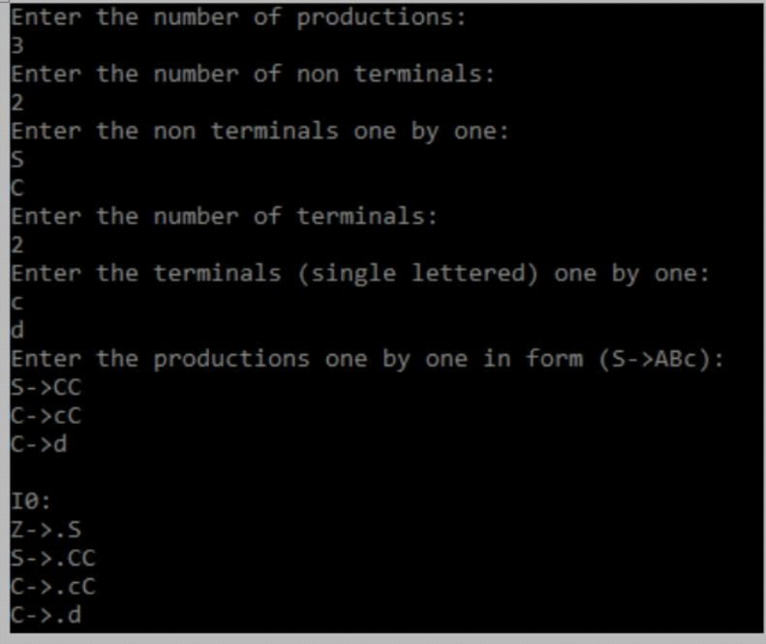
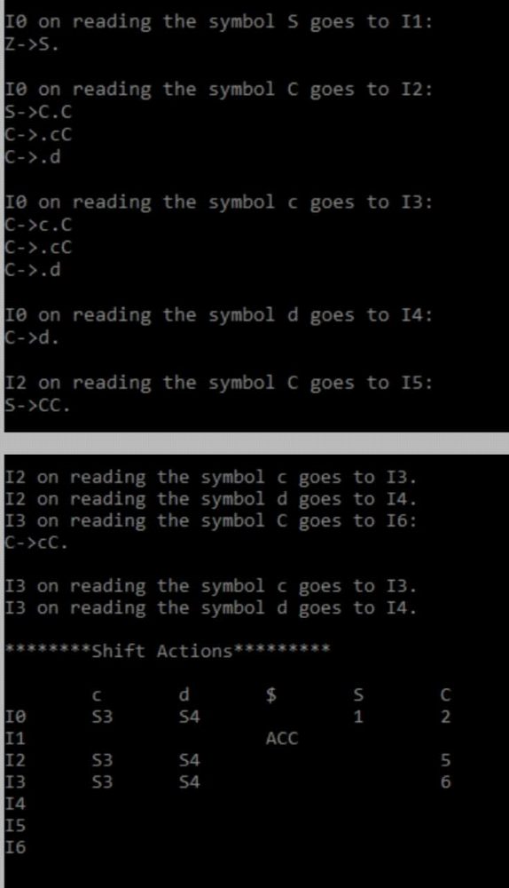
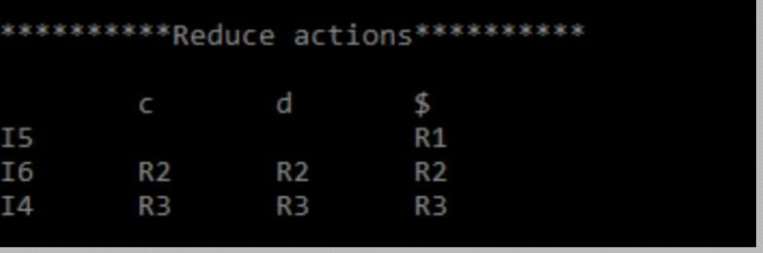

Program 11

AIM: WAP in C to draw a LL parsing table for a given grammar.
PROGRAM:
#include <stdio.h>
#include <ctype.h>
#include <string.h>
#include <stdlib.h>

void followfirst(char, int, int);
void findfirst(char, int, int);
void follow(char c);

int count, n = 0;
char calc_first[10][100];
char calc_follow[10][100];
int m = 0;
char production[10][10], first[10];
char f[10];
int k;
char ck;
int e;

int main(int argc, char **argv)
{
int jm = 0;
int km = 0;
int i, choice;
char c, ch;
printf("How many productions ? :");
scanf("%d", &count);
printf("\nEnter %d productions in form A=B where A and B are grammar symbols :\n\n", count);
for (i = 0; i < count; i++)
{
scanf("%s%c", production[i], &ch);
}
int kay;
char done[count];
int ptr = -1;
for (k = 0; k < count; k++)
{
for (kay = 0; kay < 100; kay++)
{
calc_first[k][kay] = '!';
}
}
int point1 = 0, point2, xxx;
for (k = 0; k < count; k++)
{
c = production[k][0];
point2 = 0;
xxx = 0;
for (kay = 0; kay <= ptr; kay++)
if (c == done[kay])
xxx = 1;
if (xxx == 1)
continue;
findfirst(c, 0, 0);
ptr += 1;
done[ptr] = c;
printf("\n First(%c)= { ", c);
calc_first[point1][point2++] = c;
for (i = 0 + jm; i < n; i++)
{
int lark = 0, chk = 0;
for (lark = 0; lark < point2; lark++)
{
if (first[i] == calc_first[point1][lark])
{
chk = 1;
break;
}
}
if (chk == 0)
{
printf("%c, ", first[i]);
calc_first[point1][point2++] = first[i];
}
}
printf("}\n");
jm = n;
point1++;
}
printf("\n");
printf("-----------------------------------------------\n\n");
char donee[count];
ptr = -1;
for (k = 0; k < count; k++)
{
for (kay = 0; kay < 100; kay++)
{
calc_follow[k][kay] = '!';
}
}
point1 = 0;
int land = 0;
for (e = 0; e < count; e++)
{
ck = production[e][0];
point2 = 0;
xxx = 0;
for (kay = 0; kay <= ptr; kay++)
if (ck == donee[kay])
xxx = 1;
if (xxx == 1)
continue;
land += 1;
follow(ck);
ptr += 1;
donee[ptr] = ck;
printf(" Follow(%c) = { ", ck);
calc_follow[point1][point2++] = ck;
for (i = 0 + km; i < m; i++)
{
int lark = 0, chk = 0;
for (lark = 0; lark < point2; lark++)
{
if (f[i] == calc_follow[point1][lark])
{
chk = 1;
break;
}
}
if (chk == 0)
{
printf("%c, ", f[i]);
calc_follow[point1][point2++] = f[i];
}
}
printf(" }\n\n");
km = m;
point1++;
}
char ter[10];
for (k = 0; k < 10; k++)
{
ter[k] = '!';
}
int ap, vp, sid = 0;
for (k = 0; k < count; k++)
{
for (kay = 0; kay < count; kay++)
{
if (!isupper(production[k][kay]) && production[k][kay] != '#' && production[k][kay] != '=' && production[k][kay] != '\0')
{
vp = 0;
for (ap = 0; ap < sid; ap++)
{
if (production[k][kay] == ter[ap])
{
vp = 1;
break;
}
}
if (vp == 0)
{
ter[sid] = production[k][kay];
sid++;
}
}
}
}
ter[sid] = '$';
sid++;
printf("\n\t\t\t\t\t\t\t The LL(1) Parsing Table for the above grammer :-");
printf("\n\t\t\t\t\t\t\t^^^^^^^^^^^^^^^^^^^^^^^^^^^^^^^^^^^^^^^^^^^^^^^^^^\n");
printf("\n\t\t\t=====================================================================================================================\n");
printf("\t\t\t\t|\t");
for (ap = 0; ap < sid; ap++)
{
printf("%c\t\t", ter[ap]);
}
printf("\n\t\t\t=====================================================================================================================\n");
char first_prod[count][sid];
for (ap = 0; ap < count; ap++)
{
int destiny = 0;
k = 2;
int ct = 0;
char tem[100];
while (production[ap][k] != '\0')
{
if (!isupper(production[ap][k]))
{
tem[ct++] = production[ap][k];
tem[ct++] = '_';
tem[ct++] = '\0';
k++;
break;
}
else
{
int zap = 0;
int tuna = 0;
for (zap = 0; zap < count; zap++)
{
if (calc_first[zap][0] == production[ap][k])
{
for (tuna = 1; tuna < 100; tuna++)
{
if (calc_first[zap][tuna] != '!')
{
tem[ct++] = calc_first[zap][tuna];
}
else
break;
}
break;
}
}
tem[ct++] = '_';
}
k++;
}
int zap = 0, tuna;
for (tuna = 0; tuna < ct; tuna++)
{
if (tem[tuna] == '#')
{
zap = 1;
}
else if (tem[tuna] == '_')
{
if (zap == 1)
{
zap = 0;
}
else
break;
}
else
{
first_prod[ap][destiny++] = tem[tuna];
}
}
}
char table[land][sid + 1];
ptr = -1;
for (ap = 0; ap < land; ap++)
{
for (kay = 0; kay < (sid + 1); kay++)
{
table[ap][kay] = '!';
}
}
for (ap = 0; ap < count; ap++)
{
ck = production[ap][0];
xxx = 0;
for (kay = 0; kay <= ptr; kay++)
if (ck == table[kay][0])
xxx = 1;
if (xxx == 1)
continue;
else
{
ptr = ptr + 1;
table[ptr][0] = ck;
}
}
for (ap = 0; ap < count; ap++)
{
int tuna = 0;
while (first_prod[ap][tuna] != '\0')
{
int to, ni = 0;
for (to = 0; to < sid; to++)
{
if (first_prod[ap][tuna] == ter[to])
{
ni = 1;
}
}
if (ni == 1)
{
char xz = production[ap][0];
int cz = 0;
while (table[cz][0] != xz)
{
cz = cz + 1;
}
int vz = 0;
while (ter[vz] != first_prod[ap][tuna])
{
vz = vz + 1;
}
table[cz][vz + 1] = (char)(ap + 65);
}
tuna++;
}
}
for (k = 0; k < sid; k++)
{
for (kay = 0; kay < 100; kay++)
{
if (calc_first[k][kay] == '!')
{
break;
}
else if (calc_first[k][kay] == '#')
{
int fz = 1;
while (calc_follow[k][fz] != '!')
{
char xz = production[k][0];
int cz = 0;
while (table[cz][0] != xz)
{
cz = cz + 1;
}
int vz = 0;
while (ter[vz] != calc_follow[k][fz])
{
vz = vz + 1;
}
table[k][vz + 1] = '#';
fz++;
}
break;
}
}
}
for (ap = 0; ap < land; ap++)
{
printf("\t\t\t %c\t|\t", table[ap][0]);
for (kay = 1; kay < (sid + 1); kay++)
{
if (table[ap][kay] == '!')
printf("\t\t");
else if (table[ap][kay] == '#')
printf("%c=#\t\t", table[ap][0]);
else
{
int mum = (int)(table[ap][kay]);
mum -= 65;
printf("%s\t\t", production[mum]);
}
}
printf("\n");
printf("\t\t\t---------------------------------------------------------------------------------------------------------------------");
printf("\n");
}
int j;
printf("\n\nPlease enter the desired INPUT STRING = ");
char input[100];
scanf("%s%c", input, &ch);
printf("\n\t\t\t\t\t===========================================================================\n");
printf("\t\t\t\t\t\tStack\t\t\tInput\t\t\tAction");
printf("\n\t\t\t\t\t===========================================================================\n");
int i_ptr = 0, s_ptr = 1;
char stack[100];
stack[0] = '$';
stack[1] = table[0][0];
while (s_ptr != -1)
{
printf("\t\t\t\t\t\t");
int vamp = 0;
for (vamp = 0; vamp <= s_ptr; vamp++)
{
printf("%c", stack[vamp]);
}
printf("\t\t\t");
vamp = i_ptr;
while (input[vamp] != '\0')
{
printf("%c", input[vamp]);
vamp++;
}
printf("\t\t\t");
char her = input[i_ptr];
char him = stack[s_ptr];
s_ptr--;
if (!isupper(him))
{
if (her == him)
{
i_ptr++;
printf("POP ACTION\n");
}
else
{
printf("\nString Not Accepted by LL(1) Parser !!\n");
exit(0);
}
}
else
{
for (i = 0; i < sid; i++)
{
if (ter[i] == her)
break;
}
char produ[100];
for (j = 0; j < land; j++)
{
if (him == table[j][0])
{
if (table[j][i + 1] == '#')
{
printf("%c=#\n", table[j][0]);
produ[0] = '#';
produ[1] = '\0';
}
else if (table[j][i + 1] != '!')
{
int mum = (int)(table[j][i + 1]);
mum -= 65;
strcpy(produ, production[mum]);
printf("%s\n", produ);
}
else
{
printf("\nString Not Accepted by LL(1) Parser !!\n");
exit(0);
}
}
}
int le = strlen(produ);
le = le - 1;
if (le == 0)
{
continue;
}
for (j = le; j >= 2; j--)
{
s_ptr++;
stack[s_ptr] = produ[j];
}
}
}
printf("\n\t\t\t=======================================================================================================================\n");
if (input[i_ptr] == '\0')
{
printf("\t\t\t\t\t\t\t\tYOUR STRING HAS BEEN ACCEPTED !!\n");
}
else
printf("\n\t\t\t\t\t\t\t\tYOUR STRING HAS BEEN REJECTED !!\n");
printf("\t\t\t=======================================================================================================================\n");
}

void follow(char c)
{
int i, j;
if (production[0][0] == c)
{
f[m++] = '$';
}
for (i = 0; i < 10; i++)
{
for (j = 2; j < 10; j++)
{
if (production[i][j] == c)
{
if (production[i][j + 1] != '\0')
{
followfirst(production[i][j + 1], i, (j + 2));
}
if (production[i][j + 1] == '\0' && c != production[i][0])
{
follow(production[i][0]);
}
}
}
}
}

void findfirst(char c, int q1, int q2)
{
int j;
if (!(isupper(c)))
{
first[n++] = c;
}
for (j = 0; j < count; j++)
{
if (production[j][0] == c)
{
if (production[j][2] == '#')
{
if (production[q1][q2] == '\0')
first[n++] = '#';
else if (production[q1][q2] != '\0' && (q1 != 0 || q2 != 0))
{
findfirst(production[q1][q2], q1, (q2 + 1));
}
else
first[n++] = '#';
}
else if (!isupper(production[j][2]))
{
first[n++] = production[j][2];
}
else
{
findfirst(production[j][2], j, 3);
}
}
}
}

void followfirst(char c, int c1, int c2)
{
int k;
if (!(isupper(c)))
f[m++] = c;
else
{
int i = 0, j = 1;
for (i = 0; i < count; i++)
{
if (calc_first[i][0] == c)
break;
}
while (calc_first[i][j] != '!')
{
if (calc_first[i][j] != '#')
{
f[m++] = calc_first[i][j];
}
else
{
if (production[c1][c2] == '\0')
{
follow(production[c1][0]);
}
else
{
followfirst(production[c1][c2], c1, c2 + 1);
}
}
j++;
}
}
}
